CHAPTER 9: Energy transmission
Worksheet 9.8

A step back in time
Science Quest 9: pages 331–3
Student: Class:

Dots and dashes

You will need:
power supply
buzzer or light globe
tapping switch
3 connecting leads

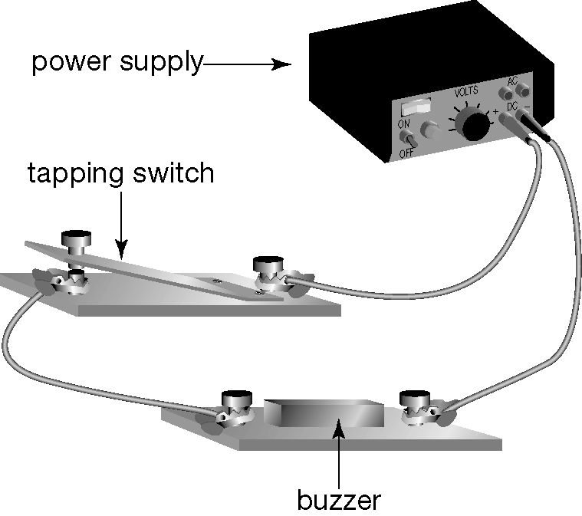

- A simple circuit for sending and receiving Morse code.

• Connect the circuit shown in the diagram above. A light globe can be used instead if a buzzer is not available.
• Test your circuit to make sure that the buzzer or light globe operates only when the switch is closed.
• Write down a short message in words without letting your partner see it. Use the Morse code key and rules on the right to write your message.

• Use the tapping switch to send the message to your partner, who will write the message down in Morse code and then translate it into words.
• Switch roles and repeat the procedure. Each person will need practice, so it is best to start with messages that consist of only two or three words.
1. Which letters are most easily or quickly transmitted?

2. Is the code random, or is there a pattern to it? If there is a pattern, what is it?

3. Which part of this communication takes the most time?

A • –  B – • • •  C – • – •  D – • •  E •  F • • – •  G – – • | H • • • •  I • •  J • – – –  K • – •  L • – • •  M – –  N – • | O – – –  P • – – •  Q – – • –  R • – •  S • • •  T –  U • • – | V • • • –  W • – –  X • • –  Y – • – –  Z – – • •
1 • – – – –  2 • • – – –  3 • • • – –  4 • • • • – | 5 • • • • •  6 – • • • •  7 – – • • •  8 – – – • • | 9 – – – – •  0 – – – – –  . (Full stop) • • • • • •  , (Comma) • – • – • –
Rules
1. A dash lasts as long as three dots.
2. A space as long as one dot is left between each pulse.
3. A space as long as one dash is left between each letter of a word.
4. A space as long as five dots is left between each word of a sentence.

